**PROGRAM 1**

Write a JAVA program to implement the class mechanism. – Create a class, define data members, and methods (setData(args),getData()), and invoke them inside the main method.

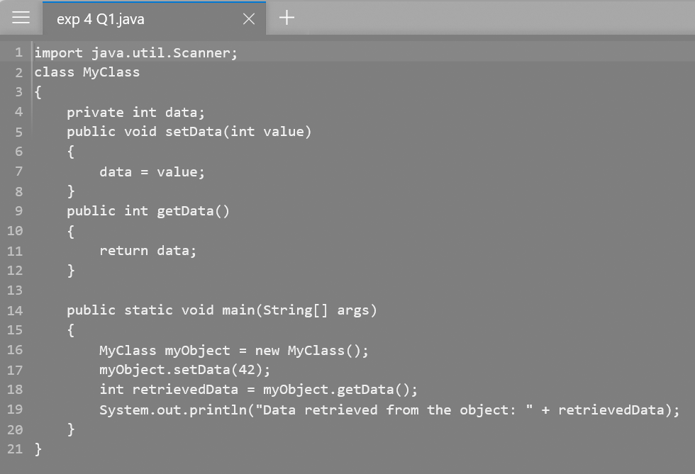

**OUTPUT**

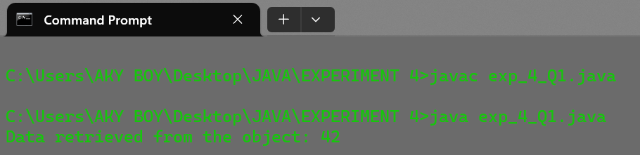

**PROGRAM 2**

Write software to prepare the results of the students for school examinations. The Roll no of the students and their marks in subjects of Physics, Chemistry, and Math are supplied through the Scanner class. The result of the subject is prepared and displayed on the output screen by finding the students who fail and pass the exam. If the marks are below 40% in the subject, then the student has failed in the subject. If the student passes and the aggregate score is above 75% then he scores Distinction. If the student passes and aggregate marks are 60%,50%, and 40% then he scores First, Second, and Third Division. Mention all the cases in output.

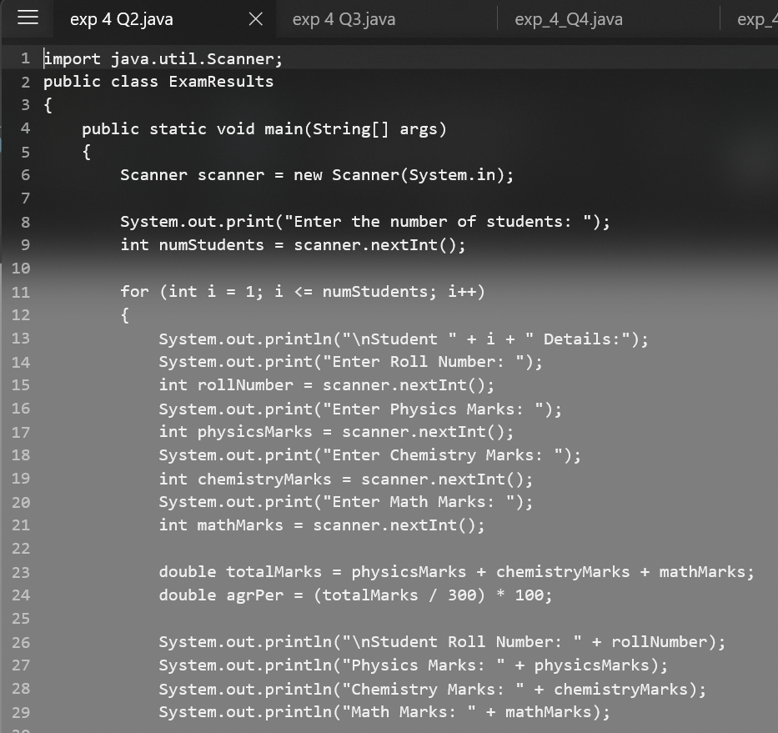

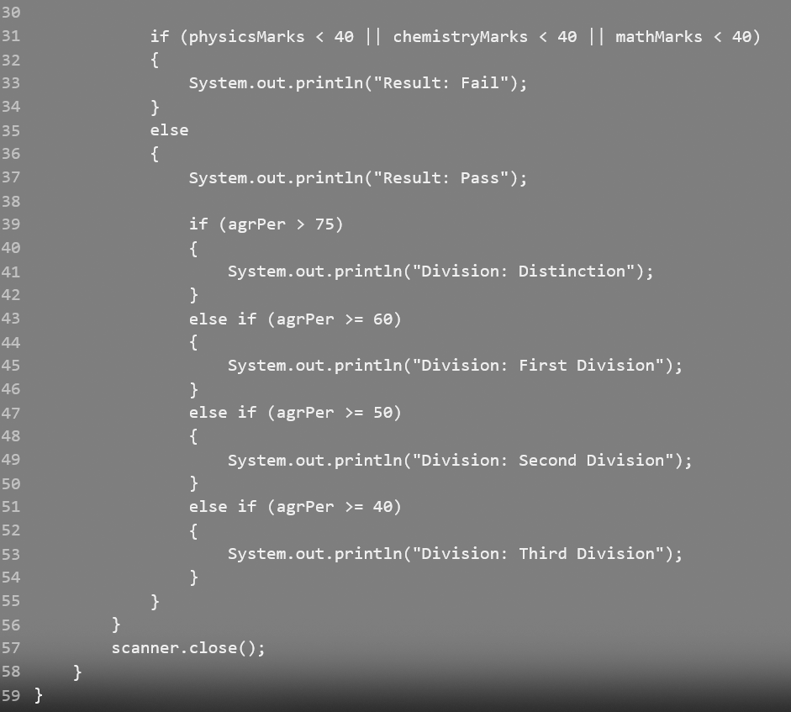

**OUTPUT**

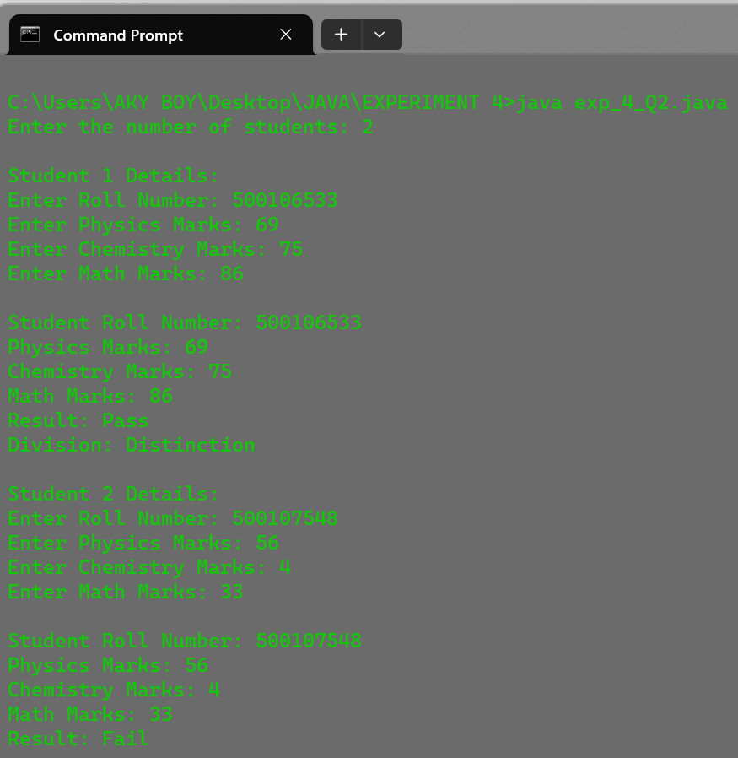

**PROGRAM 3**

Write a JAVA program to implement compile time polymorphism.

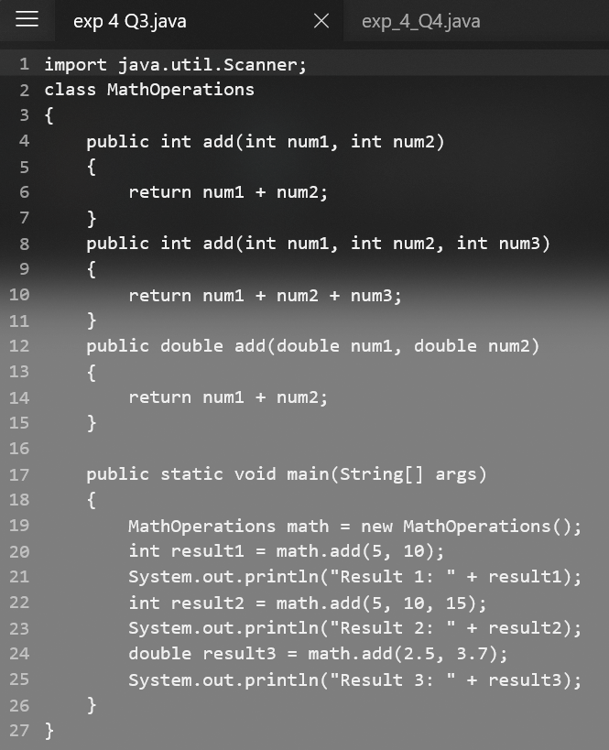

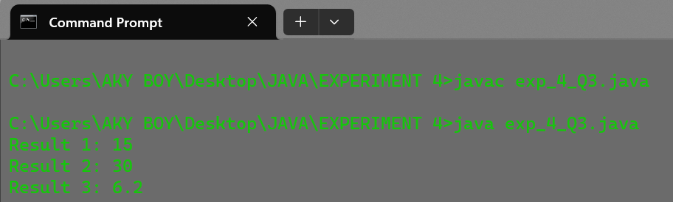**OUTPUT**

**PROGRAM 4**

Write a JAVA program to implement type promotion in method overloading.

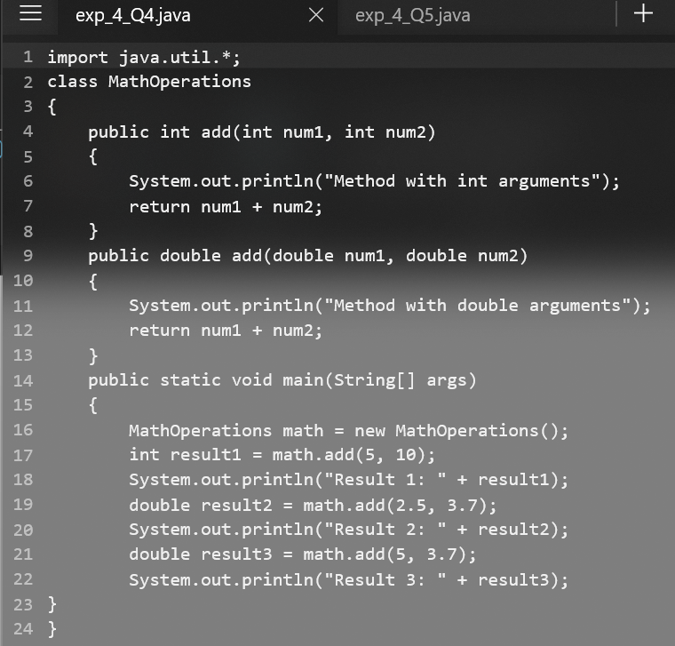

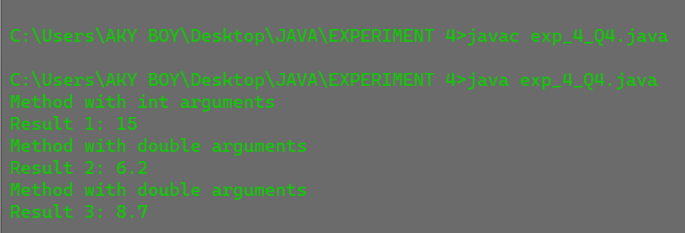**OUTPUT**

**PROGRAM 5**

Write a JAVA program to implement constructor overloading.

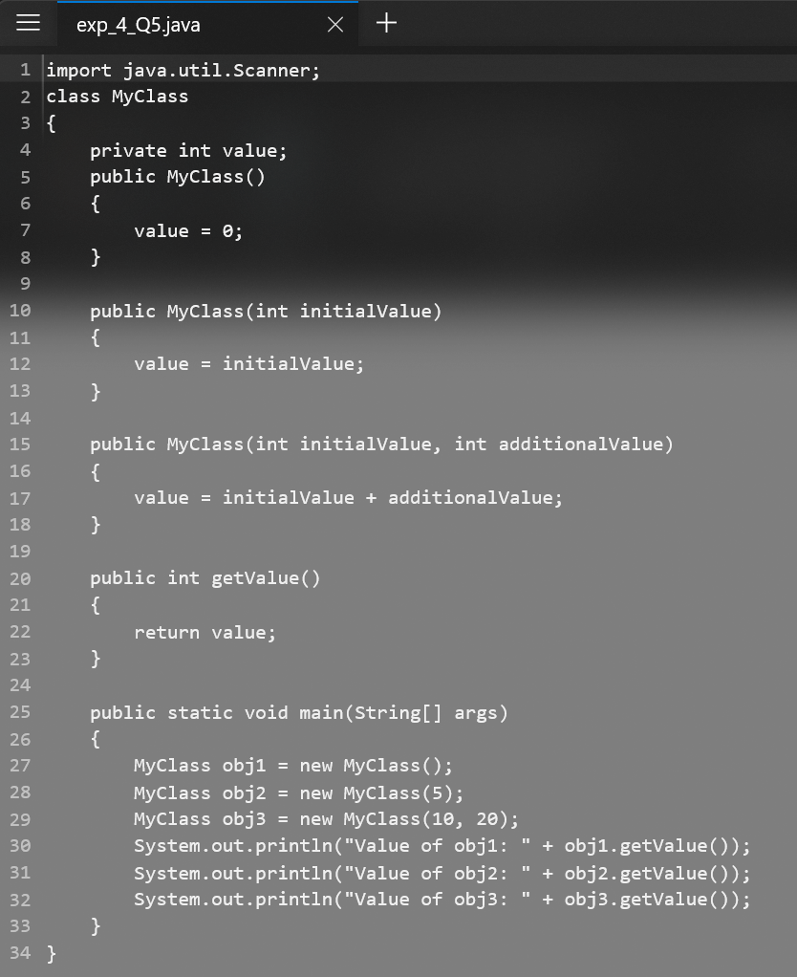

**OUTPUT**

